Phase 1: System Planning and Distribution Selection (Week 1)
1. System Architecture Diagram
Overview
This coursework implements a two-part system that mainly consists of a headless Ubuntu Server virtual machine and a separate Ubuntu Desktop workstation virtual machine that are both set up in VirtualBox. The virtual machine desktop is where the server is managed remotely through Secure Shell (SSH) and thus has command-line administration carried out remotely.
Both of the virtual machines use the same VirtualBox NAT Network, which has the advantage of allowing network communication between the systems in a controlled manner and at the same time providing internet access for package installation and updates when necessary. The server does not run a graphical user interface but is completely managed through the command-line interface (CLI).
Network Design Summary
- NAT Network: Allows for the virtual machines to have private communication and also controlled internet access
- SSH-based administration: Server is only accessed from the workstation for management
- Headless server design: Minimizes the attack surface and the usage of resources
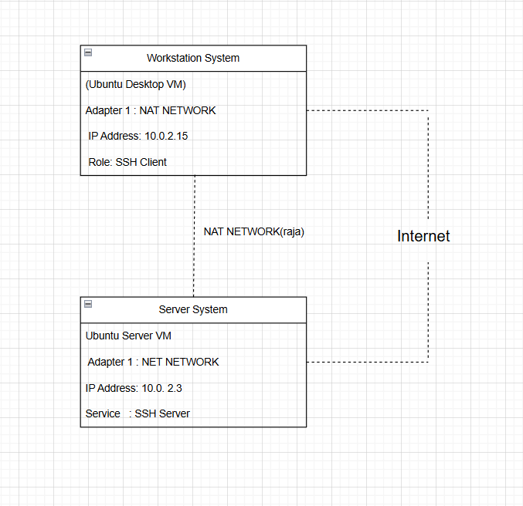
2. Distribution Selection Justification
Selected Server Operating System
Ubuntu Server 22.04 LTS
The server operating system planned for the project was Ubuntu Server 22.04 LTS due to its stability throughout time, the predictable update cycle, and the high relevance in the industry.
Advantages of Ubuntu Server LTS
- Stability and Long-Term Support: The Long-Term Support (LTS) versions are maintained for over five years, thus they can be deployed in production-like environments or the case of long-term coursework.
- Extensive Documentation: Ubuntu has a very good official and community documentation that supports troubleshooting and learning.
- Large Package Repository: It is easy to install important applications such as OpenSSH, web servers, monitoring tools, and security utilities using the apt package manager.
- Industry Adoption: Major cloud service providers such as AWS, Microsoft Azure, and Google Cloud heavily rely on Ubuntu Server.
- Resource Efficiency: The absence of a GUI leads to a reduction in CPU and memory consumption, which results in better resource efficiency.
Comparison with Alternative Distribution
Factor | Ubuntu Server LTS (Chosen) | Fedora Server
Support Cycle | 5-year Long-Term Support | ~13-month lifecycle
Stability | Highly stable and predictable | Frequent changes
Package Manager | apt | dnf
Documentation | Extensive community support | Smaller server-focused community
Coursework Suitability | Excellent for security and performance analysis | Higher maintenance overhead

Conclusion
Through weighing the factors of stability, friendliness of use, community support, and professional significance, the choice of Ubuntu Server LTS as the leading operating system for this coursework has been made.
3. Workstation Configuration Decision
Selected Workstation System
Ubuntu Desktop (GUI) running as a VirtualBox virtual machine
Justification
•Delivers a regular SSH client and terminal tools
•Offices a Linux-to-Linux administration workflow in accordance with the industry standard
•Bans any alteration or danger to the host operating system
•Guarantees working with VirtualBox Host-Only networking
•Makes fewer differences in cross-platform aspects between workstation and server
Conclusion
Server management using Ubuntu Desktop is at the top of the list when it comes to performance.
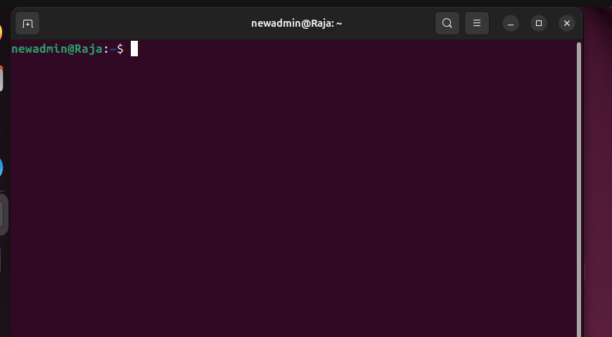
4. Network Configuration Documentation
Objective
- Facilitate SSH access from workstation to server
- Keep server isolated from outside networks
- Assign IP addresses predictably
- Permit NAT access only if necessary
VirtualBox Network Configuration
Each virtual machine is configured with two network adapters:
Adapter | Type | Purpose
Adapter 1 | NAT Network | VM-to-VM communication and internet access

Workstation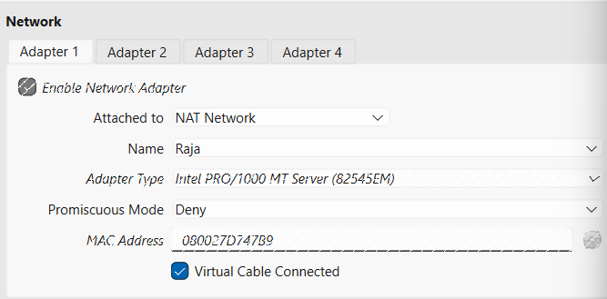

Server
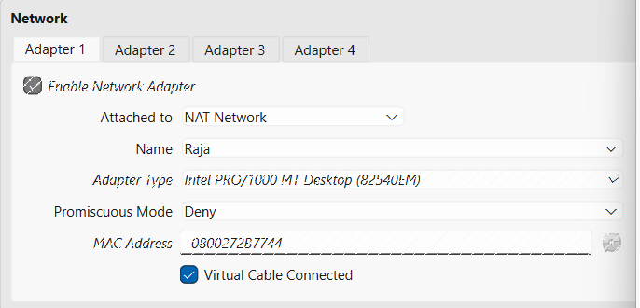

IP Addressing (DHCP)
IP addresses are assigned automatically via DHCP by the NAT Network.
Device | Network Type | IP Assignment | Purpose
Server VM | NAT Network | DHCP | SSH target
Workstation VM | NAT Network | DHCP | SSH client

Server (VM)
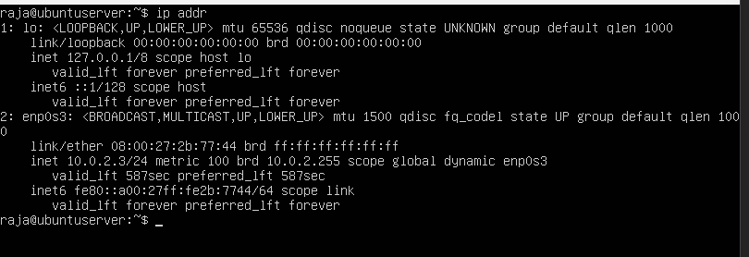
Workstation (VM)
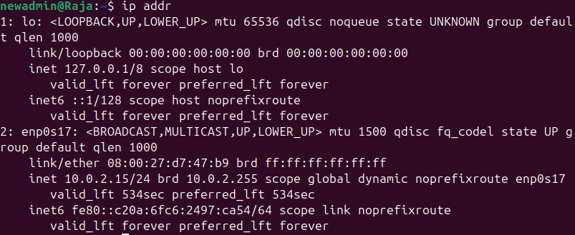

5. System Specification Documentation (CLI Evidence)
The command-line tools were used to collect all the system information, thus reinforcing the command-line proficiency that the coursework required.
5.1 Kernel and OS Information
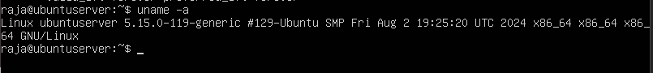
5.2 Memory Usage
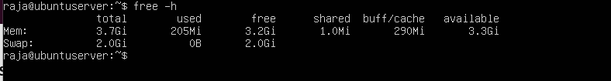
5.3 Disk Usage
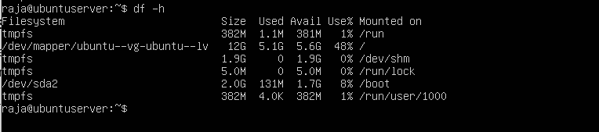
5.4 Network Interfaces
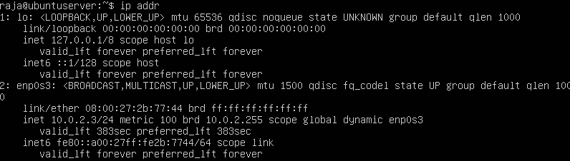
5.5 Distribution Information
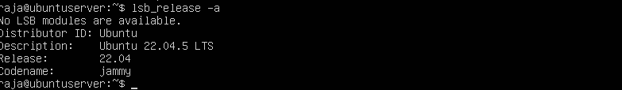
6. Initial Security Considerations
The deployment of a headless Ubuntu Server significantly decreases the possible points of attack on the system by removing nonessential graphical services. The use of a NAT Network provides an opportunity for regulated connectivity and at the same time prevents the server from being directly exposed to either the host or external networks. The various design choices made an underlying security infrastructure for the upcoming security hardening activities, like SSH key-based authentication, firewall configuration, and the setting up of intrusion prevention mechanisms.
7. Initial Design Trade-Off Analysis
During the planning stage several design trade-offs were pointed out. NAT Network use makes the connectivity process easier and internet access support but gives a less isolated environment than a Host-Only network. This trade-off is giving up the security of a separate network for the sake of easy configuration and functionality. However, OS-level security controls can still be applied in the later phase. The non-GUI server approach enhances both performance and security but at the expense of user-friendliness.
8. Summary
During the first week, a dual-system virtualized setting was successfully drawn up and set up by means of VirtualBox. One of the systems being the headless Ubuntu server was configured for remote command-line administration, and the other, that is the Ubuntu desktop workstation, was prepared for SSH access. A NAT Network was used for networking so both VMs could talk to each other and have limited internet access. The system specifications were noted through CLI tools which created a base for the advanced security controls, monitoring and performance evaluation in next weeks to come.

